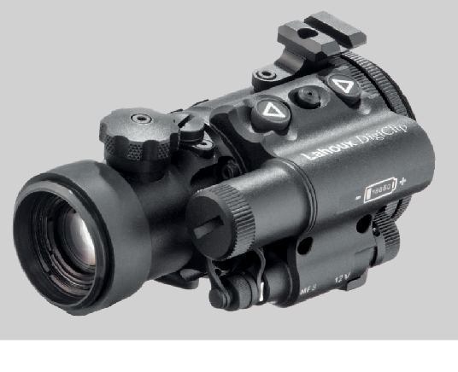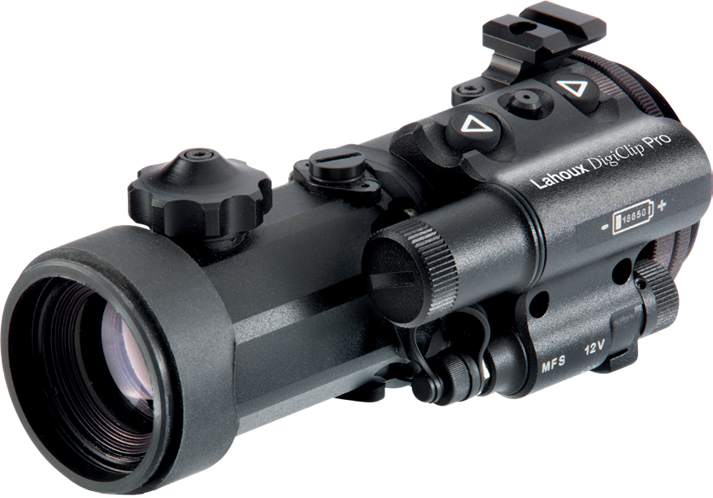
User manual

Lahoux DigiClip Lahoux DigiClip Pro

Digital attachment

Remarks
The user manual describes the use of the La- houx DigiClip and DigiClip Pro and the precau- tions for use. In order to ensure the safety of the user, the reasonable and effective maintenance and use of the Lahoux DigiClip and DigiClip Pro, as well as to ensure the normal life of
the Lahoux DigiClip and DigiClip Pro, Lahoux Optics requires the user to read the operating instructions completely and to strictly observe the regulations before the Lahoux DigiClip and DigiClip Pro is used.

The use and maintenance of the Lahoux DigiClipaand DigiClip Pro is only subject to the supplied user manual. Other materials are for reference purposes only.

If you experience any problems while using the Lahoux DigiClip and DigiClip Pro, please forward your feedback to your retailer or Lahoux Optics as soon as possible.

Contents
Preface 4
- Introduction 5
- Features 6
- Accessories 6
- Specifications 7
- Parts 8
Parts of the Lahoux DigiClip 8
Parts of the Lahoux DigiClip Pro 9
- Operation 10
  - Battery installation 10
  - Turning ON / OFF 10
  - Display brightness adjustment 10
  - Clip-on function 10
  - Optical axis collimation 11
  - IR illuminator (optional accessory). 11
- Customer support 12

Precautions

- The Lahoux DigiClip/DigiClip Pro can be used within a wide temperature range – from -20 °C to +50 °C. However, in case the device is brought from a cold to a warm environment, the image may be blurred due to condensation of the external lenses. Store the
monocular in a bag in a warm, dry and well ventilated environment at less than 95% humidity and 25 °C temperature.
- Protect the monocular against any mechanical damage.
- Protect the lenses from dirt and grease. Dirty and greasy spots deteriorate the image quality. If
necessary, clean the external lenses of an objective and eyepiece with a soft brush first, then use a tissue or cotton swab dipped in alcohol. Important! Dirt
on the lenses and rough materials may scratch the lenses.
- Always attach the clip-on with adapter to the day scope securely and clamp adapter firmly in order to shoot precisely.
- Do not submerge clip-on into water.
- It is recommended to use a ’protected’ 18650 rechargeable battery.

Notes

- The battery compartment cover should always be fixed securely.
- Do not allow water and snow ingress onto the objec- tive lens; it will deteriorate the image quality. Water does not pass heat. Please wipe the objective lens with a special soft and clean cloth.
- In case the image, before or after installation, sud- denly becomes vague or unsharp the lenses may be blurred by condensation by humidity or your breath. Check all glass surfaces (clip-on and scope) and wipe clean with a soft cloth like mentioned above.
- Target detection distance may be reduced under night, rain, fog or snow conditions.
- When the device is used as clip-on and different day scopes are used as well, it may be required to adjust the optical axis, since the clip-on has its own weight and distorts optical axis on different scopes differently.
- Do not disassemble the device yourself. In case of malfunction, contact the supplier in time. Unauthor- ized disassembly of the Lahoux DigiClip/DigiClip Pro will irrevocably void the warranty.

Preface
This User Manual provides detailed information on the operation method and precautions of the Lahoux DigiClip/DigiClip Pro digital attachment. In order to
safeguard the personal safety of operators, reasonably and effectively maintain and use the digital imager, and maintain the normal service life of the digital imager, please carefully read and strictly obey the following operation specifications before using the digital imager.

Our company shall not bear any legal responsibility for any mistake and accident caused by own reasons or reasons of any third party in the course of using this product by the user or property loss and personal injury caused by misjudgment of images.

We prepare this Manual with the purpose of facilitating users to use and understand our products. We will
try our best to ensure the accuracy of contents of this Manual, but we still cannot ensure the completeness of contents of it. Since we continuously update and upgrade our products, we reserve the right to modify this Manual at any time without prior notice.

Introduction
The Lahoux DigiClip and DigiClip Pro are digital attach- ments based on an advanced and highly-sensitive HD CMOS sensor. The sensor has 1280×720 pixels and the HD OLED display has 1280×960 pixels. It is designed to be used as an surveillance device, or as an attachment for daytime optical device to be used at night. The La- houx DigiClip and DigiClip Pro have no parallax and do normally not require zeroing because they are optically centered, having exactly 1× magnification.

Due to the high-contrast lens and high-resolution sen- sor, the device surpasses similar devices with a longer focal length in terms of characteristics and imaging. The Lahoux DigiClip Pro has a metal housing with IPX6 class protection. It has a 100% repeatability during reinstalla- tion, high recoil resistance and an ergonomic design. It is reliable and easy to handle.

The Lahoux DigiClip and DigiClip Pro are the perfect products for professional and amateur use, like hunting, security and nighttime observation. In the dark, an IR emitter must be used so that excellent image perfor- mance and a long illumination range are achieved.
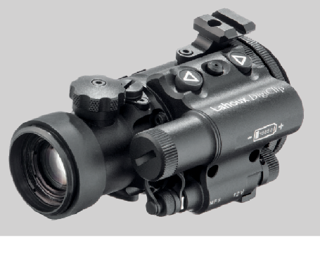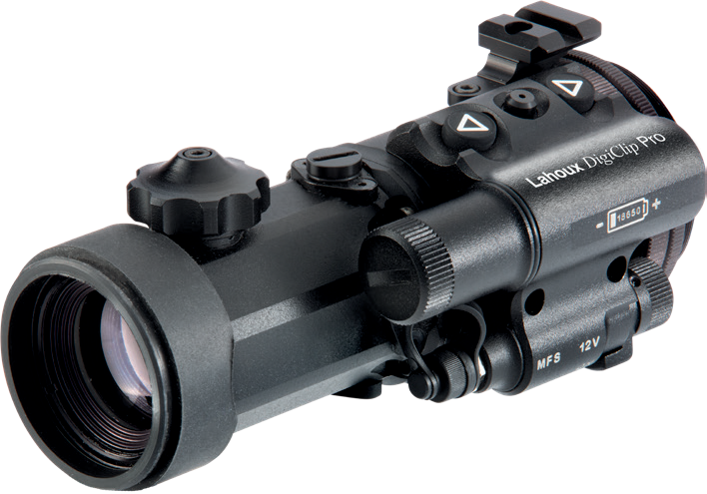

Features
- High target detection and identification distance dur- ing night and twilight with IR illuminator;
- Proven reliability and durability combined with ease of operation without any complicated menu or special settings;
- 1280×720 HD sensor with a 1280×960 HD OLED display;
- Very high recoil resistance with heavy calibers such as 12 cal., 9.3x64, .375 H&H Magnum;
- Can be used during daytime;
- Great repeatability with not more than 0.3 MOA diver- gence when repeatedly dismounted and mounted;
- Supports USB power banks.

Accessories

Packing list
Lahoux DigiClip / Lahoux DigiClip Pro digital attachment device
18650 battery and charger
Detachables eyepiece
Carrier bag
User manual

Specifications

 | Lahoux DigiClip | Lahoux DigiClip Pro
Sensor type | CMOS 1/1.8", 1280×720, PAL
Spectral range | 0.4 to 1.1 µm
Format | 1280×720 px
Frame rate | 50 Hz
Sensitivity | 0.0001 to 30,000 Lux
Resolution | 67 lp/mm
Clip-on visual magnification | 1×
Eyepiece visual magnification | 4× | 2.5×
Day sight recommended magnification | 1-12× | 1-15×
Lens | 36 mm F/1.4 | 54 mm F/1.5
Lens focusing range | 6m to ∞
Detection range (boar) | 400 m | 500 m
Display | Colour OLED 1280×960 pixels
FOV | 9°×12° | 7°×11°
Diopter adjustment | +3 to -3 D | +3 to -4 D
Quick release adapter | Lahoux or Rusan adapter M52x0.75 mm
Battery | 1 x 18650
Battery runtime | 4 hours (at 24 °C)
External power | 3.2-15 V
Weight (without battery) | 480 g | 560 g
Dimensions | 128×60×70  mm | 167×75×70  mm
Working temperature range | -20°C - +50°C
Protection class IEC 60529 | IPX6
Max. recoil energy | 500 g

Parts

Parts of the Lahoux DigiClip
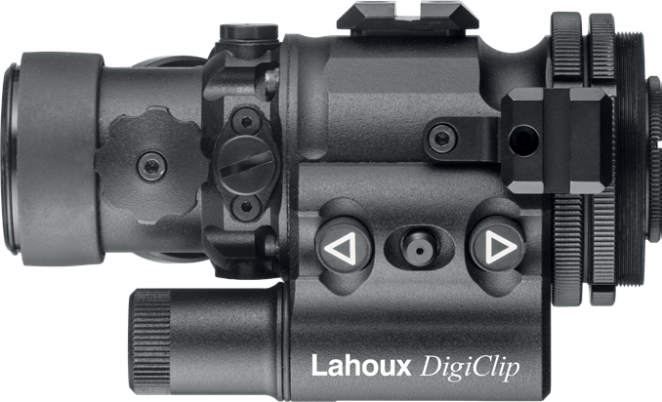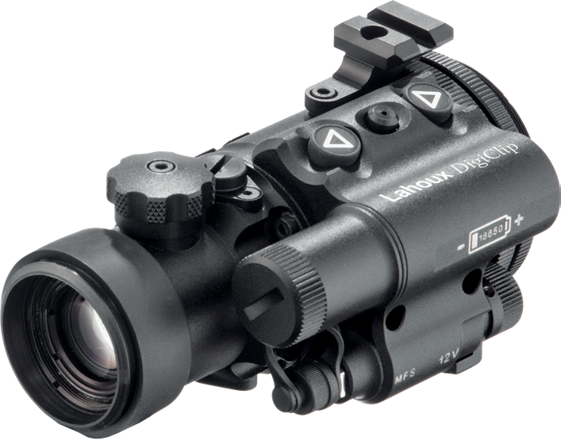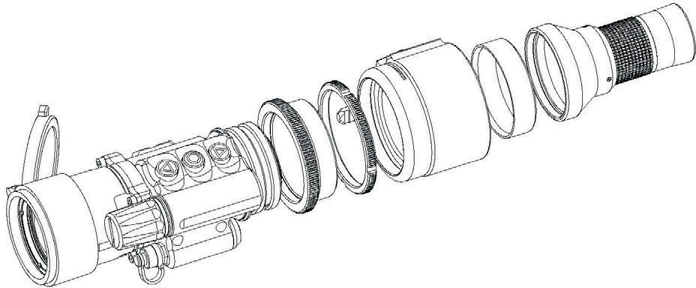1 5 4
9
2
8
1
3
5
7
6
10
11
13
12

- Focusing knob
- Battery compartment cover
- Brightness control buttons
- Clip-on/eyepiece thread
- Adjustment mechanism for positioning of the optical axis (see chapter 6.5)
- 3.2-12.5V external power socket /video output

Parts of the Lahoux DigiClip Pro
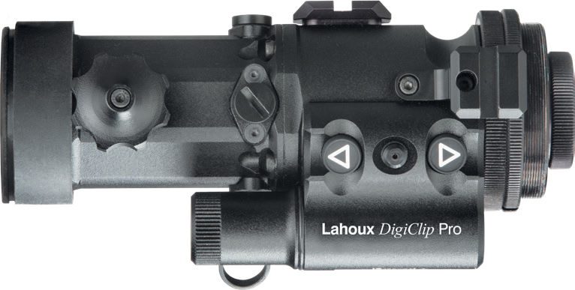1 5 4

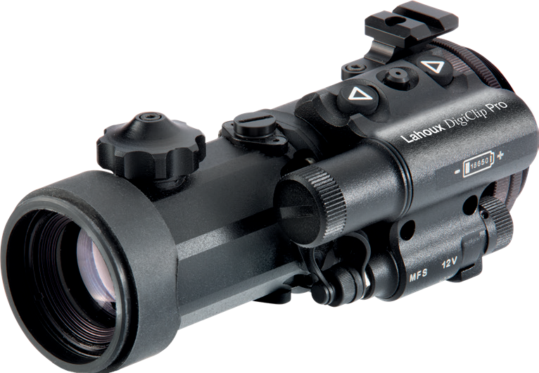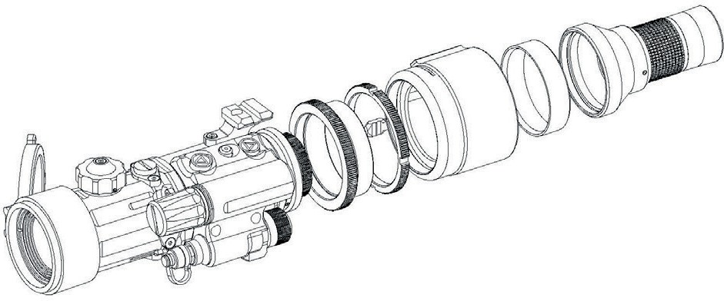
2
3
8
9
1
5
6
7
12
11
10
13

- On/off/external power selection switch
- Control power indicator
- Picatinny base
- Eyepiece
- Reducing ring for eyepiece
- Lahoux or RUSAN Quick release adapter
- Reducing and lock ring for eyepiece and adapter

Operation

Battery installation
Unscrew battery compartment cover (2). Insert protect- ed 18650 rechargeable battery, observing polarity. Place battery compartment cover back and screw on tightly.

Turning ON / OFF
Turn the switch (7) to the “ON” position to switch on the device, the control indicator (8) will light up.
Adjust the sharpness of the image by rotating the eye- piece (10) and the focusing knob (1).

Display brightness adjustment
Use the brightness control buttons (3) to set the display brightness.

Clip-on function
Lahoux Digiclip as clip-on is intended for use with daytime optical devices at night and during the day if necessary.
- Unscrew and take off eyepiece with ring (10)
- Screw the reducing rings into the thread and fix hand tight. Screw the Quick release adapter onto the reducing ring and adjust its position with the lock ring until it is in the desired position. Screw on hand tight only just enough that it won’t rotate under normal use.
- Install clip-on on your daytime optical device and ad- just the adapter according to the instructions below:
  - Loosen the stub screw at the rear of the adapter using the provided hex key.
  - Tighten or loosen the large cylinder head screw to adjust the tightness of the adapter using the larger one of the supplied hex keys.
  - Tighten the stub screw at the rear once the ad- justment is done.
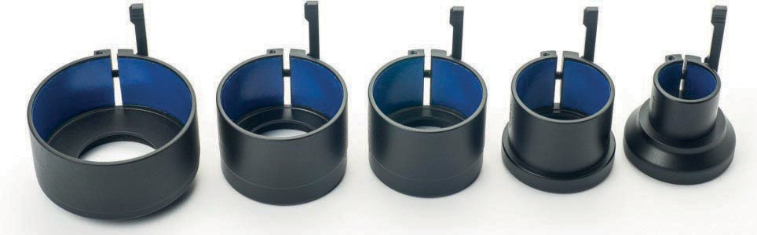
Quick release adapters

Optical axis collimation
This attachment is factory adjusted in such a way, that normally no further collimation is needed.
Should there be a need to adjust the attachment after test firing, it is possible to adjust the point of impact.

We advise to have this done by a competent gun smith. The following should be performed in order to adjust the clip-on properly:
- Aim your scope’s reticle at the center of a target pref- erably at 100 meters distance. Fix it securely;
- Install the clip-on on as instructed;
- Check whether the sight picture still matches with the center of target
- If YES – no other adjustment is required
If NO – it is necessary to adjust optical axis

Adjusting the optical axis
- Screw out the 2 protective caps (5). Break the seal of the adjustment screws and align very gently both directions with the center of target using a properly fitting flat screwdriver.
- Test shoot your rifle first (at least a group of 3 shots) and test shoot next with the Clip-on.
- Verify if the two groups overlap. If required, repeat the adjustment. After completing the zeroing, seal the ad- justment screws and reinstall the protective caps (5).
  - IR illuminator (optional accessory). Install IR illuminator on the Picatinny base (10) de- scribed in the IR illuminator’s manual.

Customer support
Should you experience any difficulties with your Lahoux Optics product, consult the manual first. If the problem remains, please contact your dealer for any question
or service. Alternatively you can contact the service- centre of Lahoux Optics for technical and service related questions: services@lahouxoptics.nl.

To return products, please first request an RMA number from the service department of your supplier. Return shipments directly to your supplier. Lahoux Optics accepts no responsibility for returns without an RMA number.

© Lahoux Optics B.V.
Stephensonstraat 47, 2014 KC Haarlem, The Netherlands www.lahouxoptics.com - info@lahoux.nl
Lahoux DigiClip Pro EN V1.01 13-08--2021

